CprE 381 – Computer Organization and

Assembly-Level Programming

Lab-03 Report

Student Name Mason Walls

Section / Lab Time Section 6 / 4:10pm to 6:00 pm

Submit a typeset pdf version of this on Canvas by the due date (i.e., the start of your next lab section). Refer to the highlighted language in the Lab-03 instructions for the context of the following questions.

- [Prelab] At the end of Chapter 5, answer question 5. At the end of Chapter 7, answer exercise 2.

- [Prelab] In your Lab #3 report PDF, provide the Canvas group name for your project team, and a listing of its members. On a scale of 1-10, how comfortable with VHDL does each team member currently feel?

Sect-06.Group-04. I am at about a 7 with VHDL, and my partner is at a 6

- [Part 1 (a)] Draw the interface description for the MIPS register file. Which ports do you think are necessary, and how wide (in bits) do they need to be?
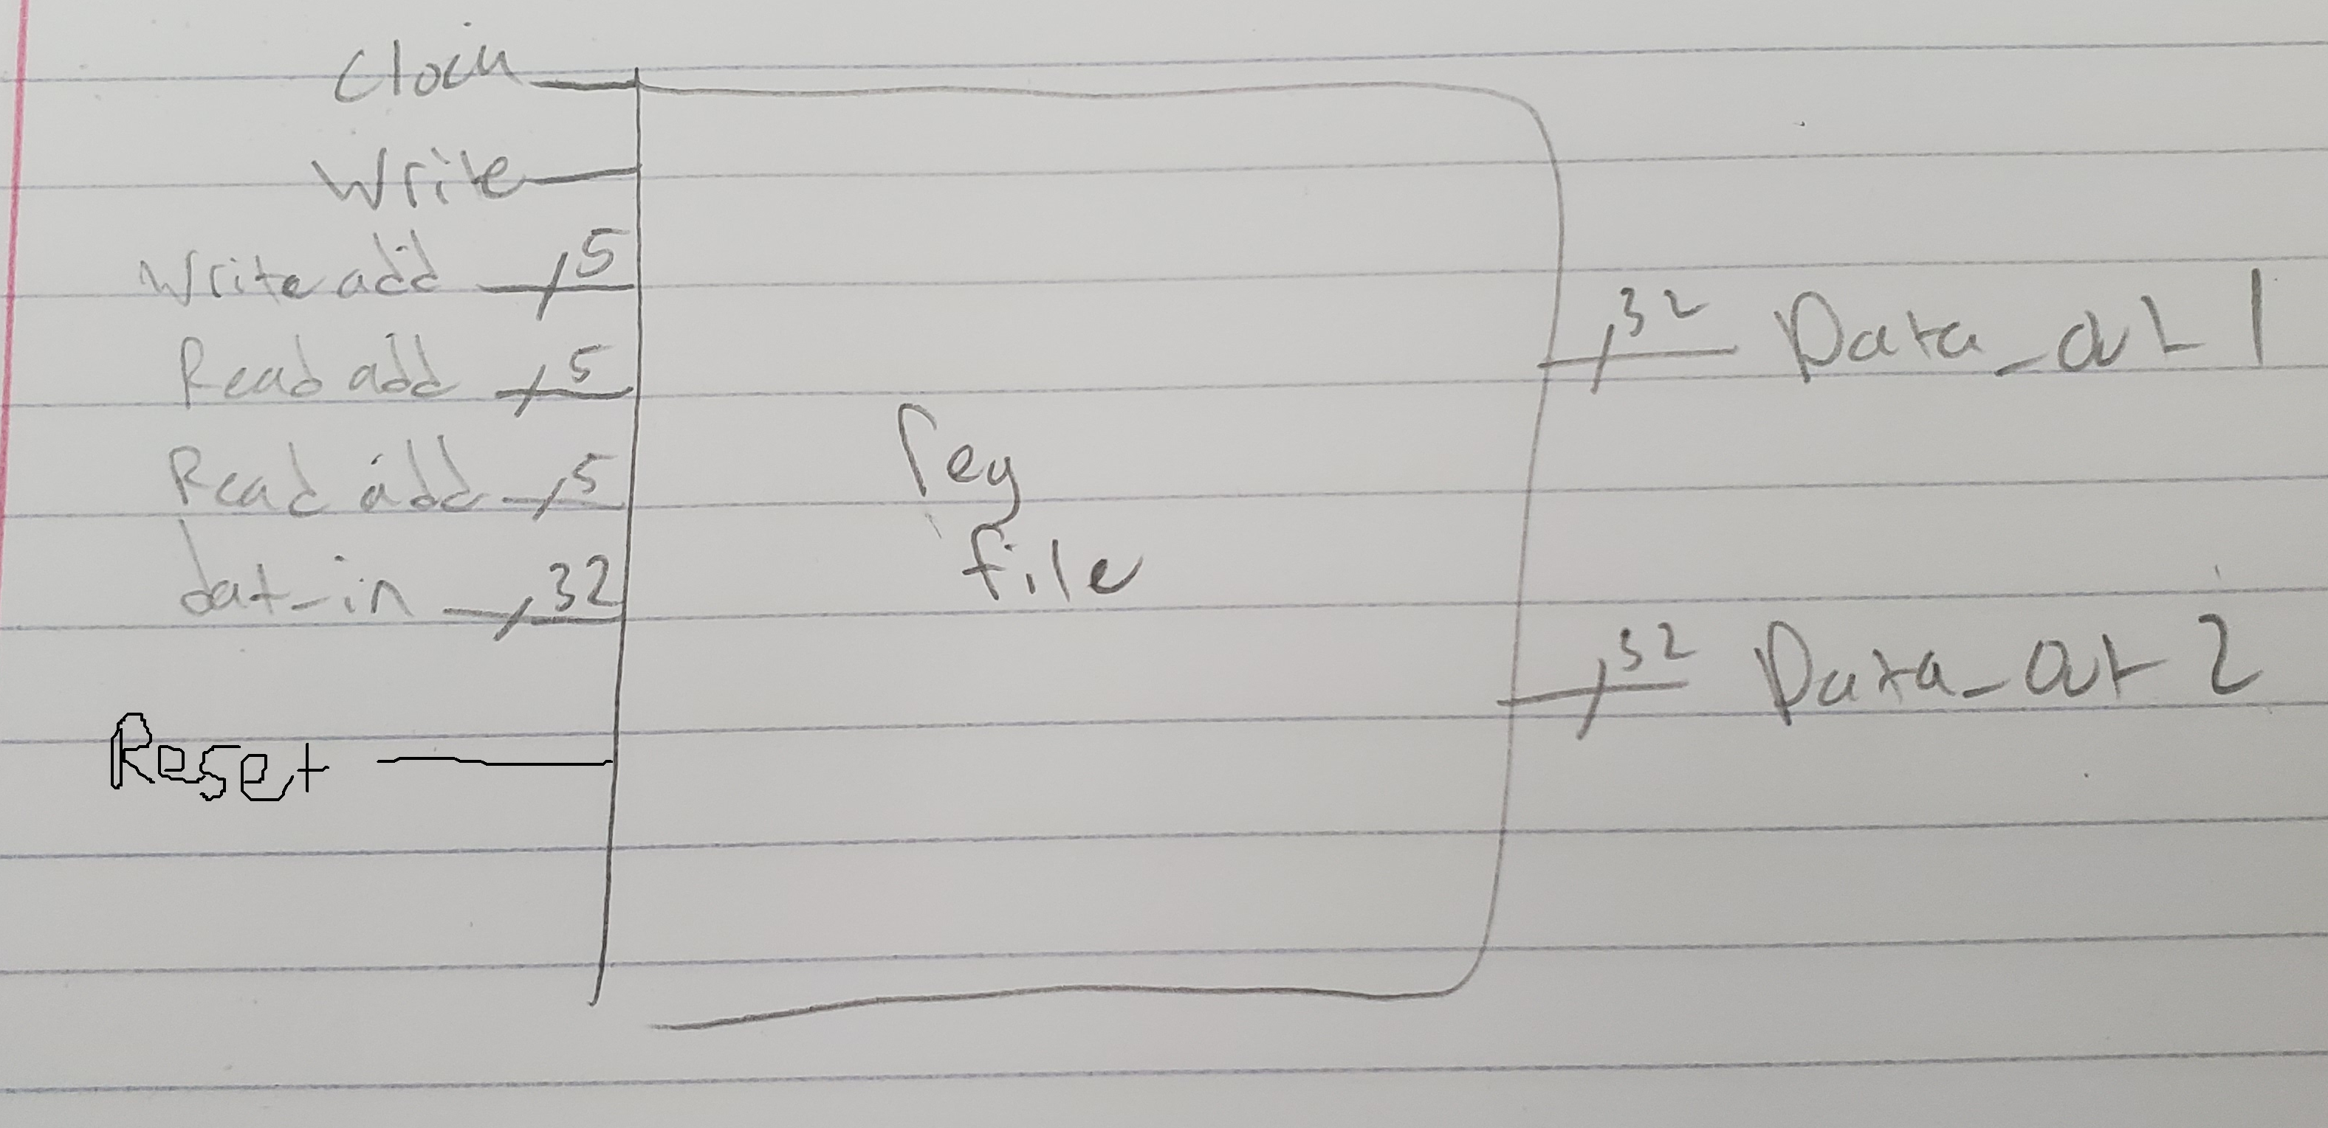

- [Part 1 (c)] Waveform.
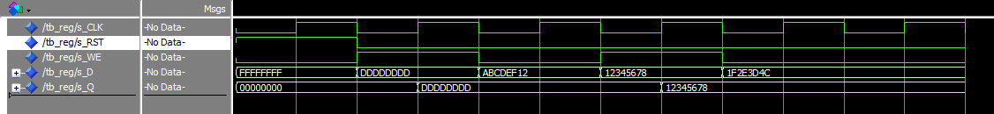

- [Part 1 (d)] What type of decoder would be required by the MIPS register file and why?
A 5 to 32 decoder is required because we need 32 different 1 bit high outputs. 5 bits can go from 0 to 31.

- [Part 1 (e)] Waveform.
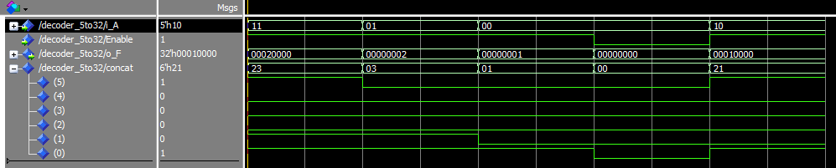

- [Part 1 (f)] In your write-up, describe and defend the design you intend on implementing for the next part.
What I did for the multiplexor was use a new type, that allowed me to make an array of 32 32bit items, then select these items using a 5 bit input. This greatly simplified the task of creating and using a 32 to 1 multiplexor

- [Part 1 (g)] Waveform.
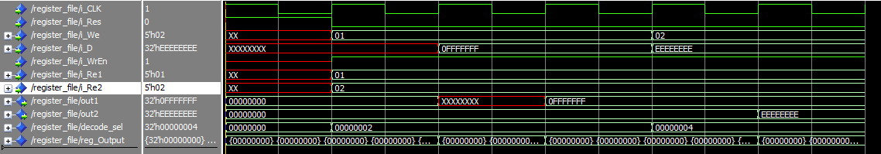

- [Part 1 (h)] Draw a (simplified) schematic for the MIPS register file, using the same top-level interface ports as in your solution for part a), and using only the VHDL components you have created in parts (b), (e), and (g).

- [Part 1 (i)] Waveform.
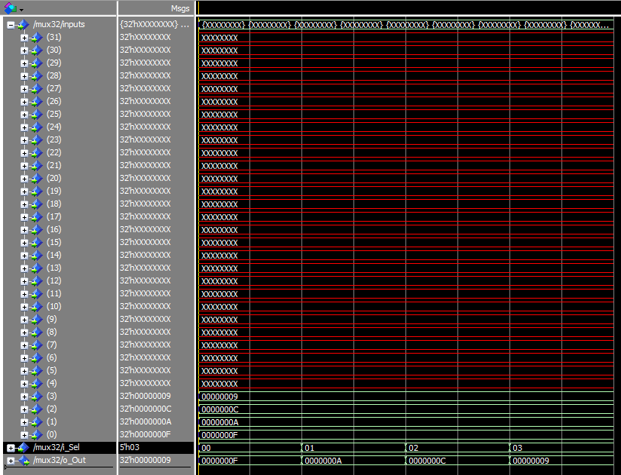
Didn’t test every input because it would take forever.
- [Part 2 (b)] Draw a schematic of the simplified MIPS processor datapath consisting only of the component described in part (a) and the register file from problem (1).

- [Part 2 (c)] Include in your report waveform screenshots that demonstrate your properly functioning design.

- [Feedback] You must complete this section for your lab to be graded. Write down the first response you think of; I expect it to take roughly 5 minutes (do not take more than 10 minutes).

  - How many hours did you spend on this lab?

Task | During lab time | Outside of lab time
Reading lab
Pencil/paper design
VHDL design
Assembly coding
Simulation
Debugging
Report writing
Other:
Total

  - If you could change one thing about the lab experience, what would it be? Why?

  - What was the most interesting part of the lab?

